DATABASE SYSTEMS ENGINEERING AND DISTRIBUTED BACKEND DEVELOPMENT
Spring Boot with Rest API and CRUD Operations

Project Structure:
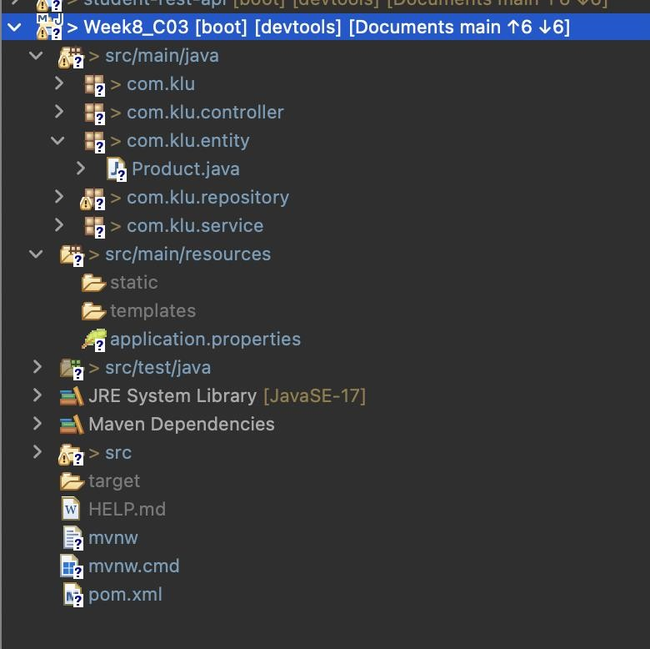
MySQL Server:
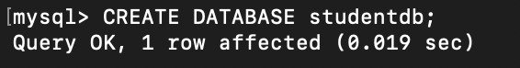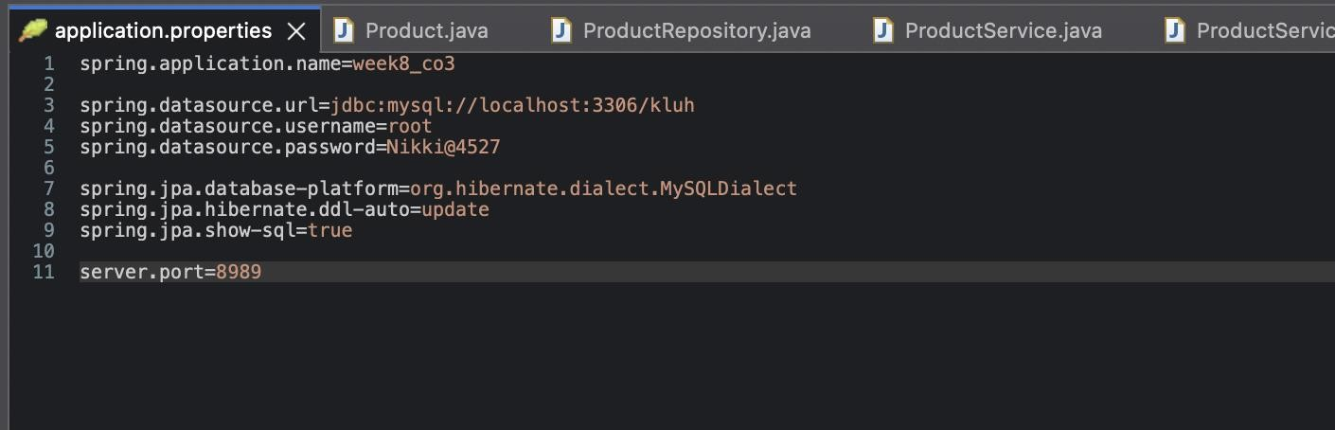

Postman:
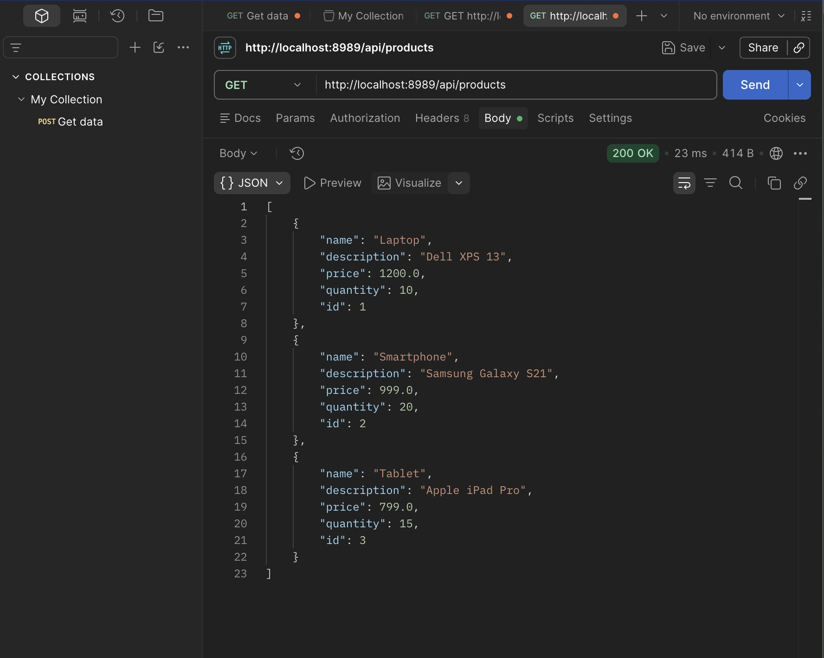
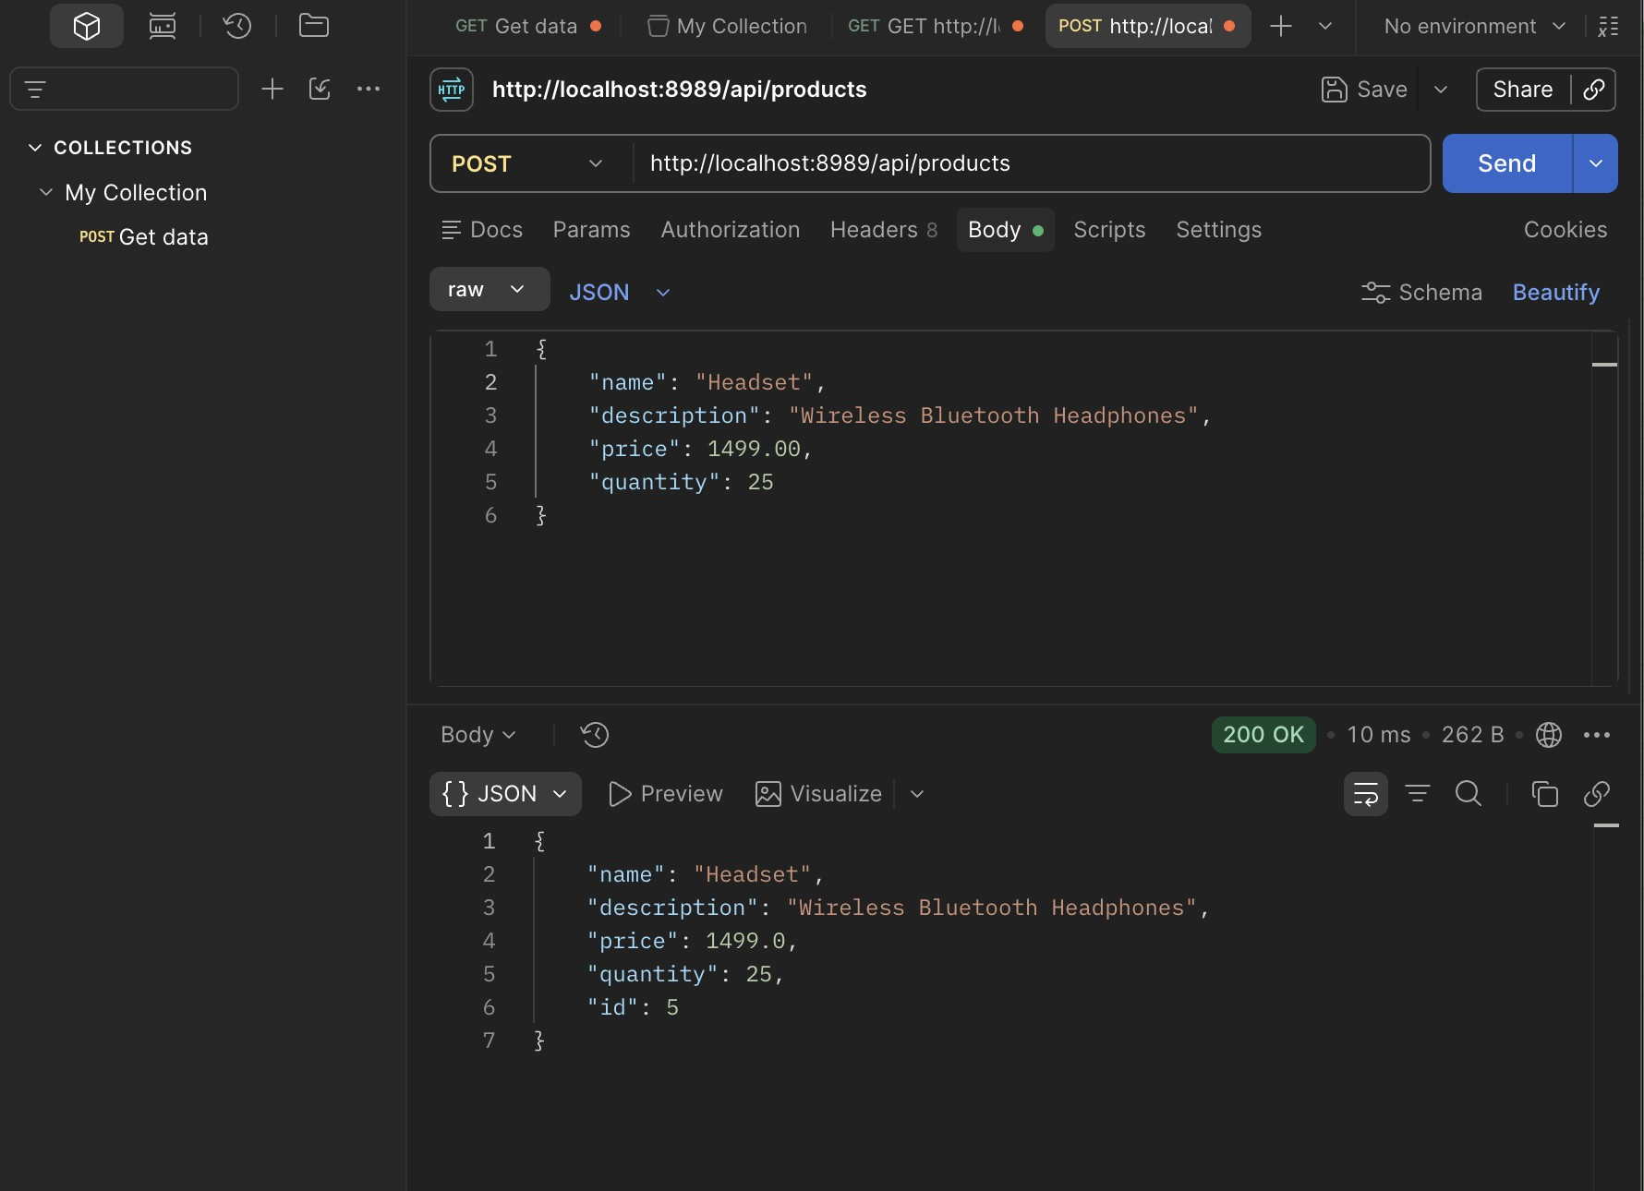
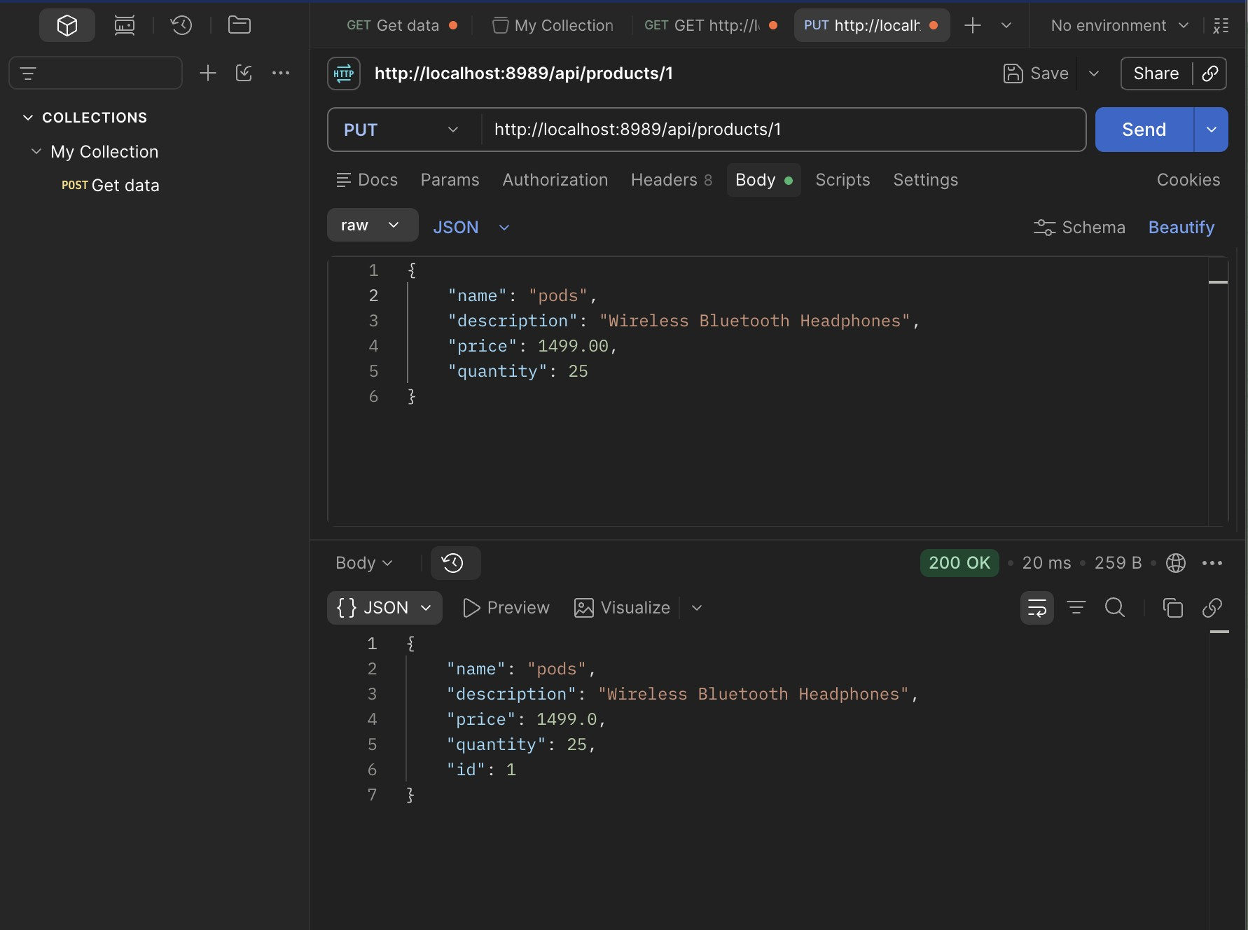

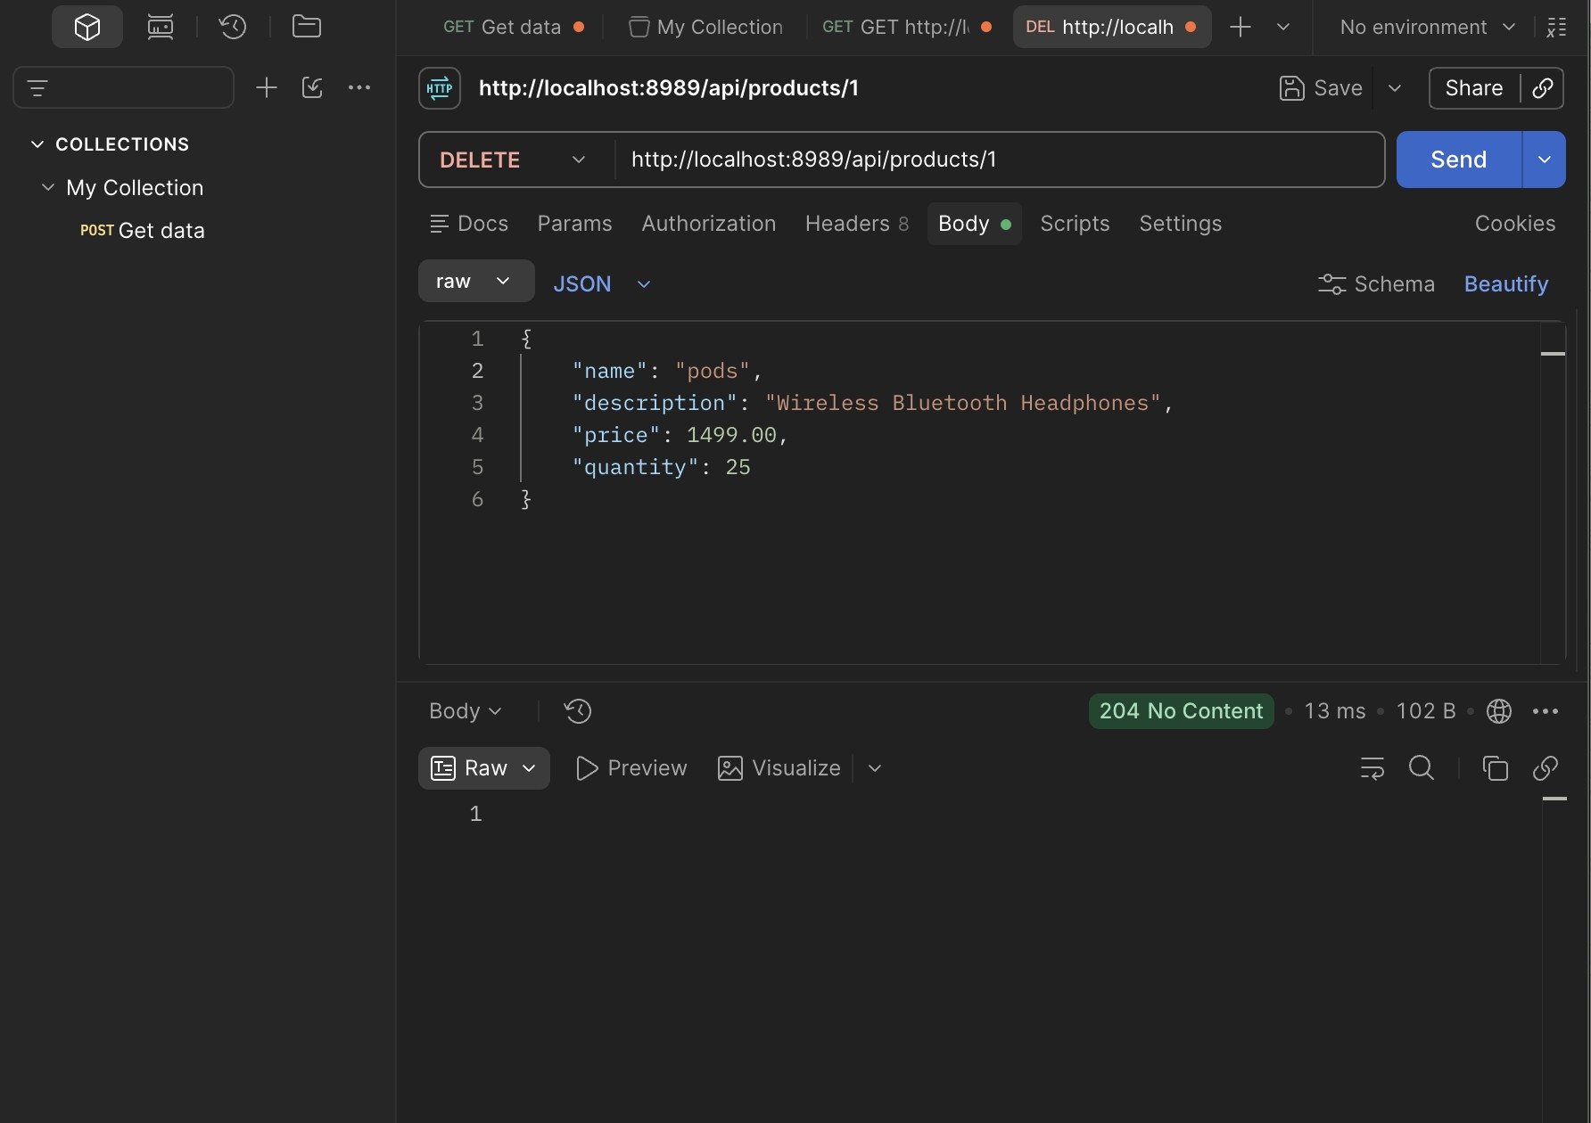

Test it with MySQL Server:
